Design and Implementation of High-Performance
FIR Filter for Real-Time Audio Signal Processing
A Project Based Learning Report Submitted in partial fulfilment of the requirements for the award of the degree

of

Bachelor of Technology
in The Department of Electronics and Communication Engineering
23VLS3303A and VLSI PHYSICAL DESIGN AUTOMATION
23SDEC18A and VLSI SUBMICRON DESIGN AND VERIFICATION
23VLS3202R and TESTING AND VERIFICATION OF VLSI CIRCUITS

Submitted by
2310040023: K. Yasawini
2310040072: G. Akshaya
2310049146: Kashifa Konain

Under the guidance of
Dr. Kasi Bandla, Dr. Kayam SaiKumar,Dr. N. Phalguni Singh & Dr.Vivek Singh


Department of Electronics and Communication Engineering
Koneru Lakshmaiah Education Foundation, Aziz Nagar
Aziz Nagar – 500075
April- 2025

TABLE OF CONTENTS:
S.NO | TOPIC NAME | PAGE NO
1. | ABSTRACT | 3
2. | INTRODUCTION | 4
3. | PROBLEM STATEMENT | 5
4. | OBJECTIVEs | 5
5. | LITERATURE REVIEW | 6
6. | SYSTEM ARCHITECTURE | 7
7. | METHODOLOGY | 10
8. | IMPLEMENTATION DETAILS | 13
9. | RESULT & ANALAYSIS | 16
10. | CONCLUSION | 19
11. | FUTURE SCOPE | 20
12. | REFERENCE | 20

ABSTRACT

Real-time digital signal processing applications such as audio enhancement, wireless communication, biomedical instrumentation, and multimedia systems require high-speed and low-latency filtering operations. In such systems, digital filters are used to remove unwanted frequency components while preserving the desired signal content. However, software-based implementations running on general-purpose processors often suffer from limited processing speed, increased latency, and inefficient handling of high data rates. As sampling frequencies increase and real-time constraints become stricter, conventional software solutions fail to meet performance requirements. Therefore, there is a critical need for a high-speed, hardware-based digital filtering solution capable of operating reliably at high clock frequencies while maintaining accuracy and stability.

To address this challenge, this project presents the design and implementation of a 16-tap pipelined Finite Impulse Response (FIR) low-pass filter using FPGA technology. FIR filters are chosen due to their inherent stability, linear phase characteristics, and suitability for hardware implementation. The filter is designed for real-time audio processing with a sampling frequency of 48 kHz and specified passband and stopband requirements. Filter coefficients are generated using the Parks–McClellan algorithm in MATLAB to achieve optimal equiripple performance. The coefficients are then quantized to 16-bit fixed-point representation to enable efficient hardware realization.

The hardware implementation is developed using Verilog Hardware Description Language (HDL). A pipelined architecture is adopted to minimize the critical path delay and significantly improve the maximum achievable clock frequency. By inserting pipeline registers across the multiplier and adder stages, the design achieves higher throughput while maintaining manageable latency. The design is synthesized and implemented using Xilinx Vivado Design Suite. Static Timing Analysis (STA) is performed to ensure timing closure and validate that setup and hold time constraints are satisfied.

Functional verification is carried out through simulation, where the hardware output is compared against MATLAB-generated golden reference results. The frequency response, passband ripple, and stopband attenuation are analyzed to confirm compliance with design specifications. The final implementation successfully achieves a clock frequency greater than 100 MHz with positive timing slack, demonstrating effective pipelining and optimization. Resource utilization analysis shows efficient use of FPGA resources, including DSP blocks, look-up tables (LUTs), and flip-flops.

The results confirm that the proposed pipelined FIR filter architecture provides high-speed operation, accurate frequency response, and efficient hardware utilization. This project effectively integrates theoretical digital signal processing concepts with practical VLSI implementation techniques, offering a scalable and high-performance solution for real-time signal processing applications.

INTRODUCTION

Digital Signal Processing (DSP) is a core area of modern electronics that focuses on analyzing and modifying signals in digital form. A signal represents information such as sound, communication data, or biomedical measurements. In most modern systems, analog signals are first converted into digital form using Analog-to-Digital Converters (ADC), after which mathematical algorithms are applied to improve signal quality, remove noise, or extract useful features. DSP is widely used in audio processing, wireless communication, image processing, radar systems, and biomedical applications.

One of the most important operations in DSP is digital filtering. A digital filter is used to selectively allow certain frequency components of a signal to pass while suppressing unwanted frequencies. Filters are essential in applications such as noise reduction, echo cancellation, signal enhancement, and channel equalization. Digital filters are broadly classified into two types: Finite Impulse Response (FIR) filters and Infinite Impulse Response (IIR) filters.

A Finite Impulse Response (FIR) filter is defined as a filter whose response to an impulse input settles to zero after a finite number of samples. The output of an FIR filter is calculated as a weighted sum of the current and previous input samples. For an N-tap FIR filter, the output equation is given by:
$$y[n]=\sum_{k=0}^{N-1}{h[k]⋅x[n-k]}$$
where $x[n]$is the input signal, $h[k]$represents the filter coefficients, and $y[n]$is the output signal. The filter coefficients determine the frequency response characteristics such as passband range, stopband attenuation, and ripple specifications. These coefficients are typically designed using tools such as MATLAB based on required performance parameters.

FIR filters are preferred over IIR filters in many hardware implementations due to several important advantages. First, FIR filters are inherently stable because they do not use feedback loops. In contrast, IIR filters rely on feedback structures that can lead to instability if not carefully designed. Second, FIR filters can achieve linear phase response, meaning all frequency components are delayed equally. This prevents distortion of the signal waveform, which is especially important in audio and biomedical applications. Third, FIR filters have a simple feedforward structure consisting of delay elements, multipliers, and adders, making them well suited for parallel and pipelined hardware architectures.
In real-time signal processing systems, high throughput and low latency are critical requirements. Software-based implementations running on general-purpose processors often suffer from limited speed and increased delay, especially as the number of filter taps increases. Each output sample requires multiple multiply-and-accumulate operations, which can be computationally intensive in sequential processing environments.

To address these limitations, hardware implementation using Field Programmable Gate Arrays (FPGAs) provides an efficient solution. FPGAs offer parallel processing capability, dedicated DSP blocks for fast multiplication, and configurable logic resources. By using pipelined architectures, the critical path delay can be reduced, enabling operation at higher clock frequencies. In this project, a 16-tap low-pass FIR filter is designed for real-time audio processing with a sampling frequency of 48 kHz. The filter coefficients are generated using MATLAB, and the design is implemented in Verilog HDL using a pipelined architecture. The implementation is synthesized and verified using Xilinx Vivado tools to ensure high-speed and accurate performance.

PROBLEM STATEMENT:

Digital signal processing systems used in real-time applications such as audio enhancement, wireless communication, and biomedical instrumentation require high-speed and low-latency filtering operations. In many practical scenarios, signals must be processed continuously at high sampling rates without delay or distortion. However, conventional software-based implementations of Finite Impulse Response (FIR) filters running on general-purpose processors often face significant limitations in terms of throughput, latency, and computational efficiency.
An FIR filter requires multiple multiplication and accumulation (MAC) operations for each output sample. For example, a 16-tap FIR filter requires 16 multiplications and 15 additions per sample. When implemented in software, these operations are executed sequentially, which increases execution time and limits the maximum achievable processing speed. As the sampling rate increases or the filter order grows, the computational burden becomes even more significant. This leads to higher latency, reduced real-time capability, and inefficient utilization of system resources.
In real-time audio processing systems operating at a sampling frequency of 48 kHz and beyond, the filter must process each input sample within a strict time constraint. Any delay beyond this limit can result in signal distortion, buffering issues, or degraded system performance. Additionally, high-performance applications require operation at clock frequencies of 100 MHz or higher to support parallel data processing and future scalability.
Therefore, there is a clear need for a hardware-based high-performance FIR filter implementation capable of achieving high throughput, low latency, and reliable operation at clock frequencies exceeding 100 MHz. The solution must efficiently utilize hardware resources, maintain accurate frequency response characteristics, and meet timing constraints verified through Static Timing Analysis (STA).
This project addresses these challenges by designing and implementing a 16-tap pipelined FIR filter using FPGA technology, ensuring real-time processing capability, improved speed, and optimized hardware performance.

OBJECTIVES:

The primary objective of this project is to design and implement a high-performance 16-tap low-pass Finite Impulse Response (FIR) filter suitable for real-time digital signal processing applications. The specific objectives of the project are as follows:
- To design a 16-tap low-pass FIR filter
Develop a digital filter capable of allowing low-frequency components to pass while attenuating higher-frequency components based on defined passband and stopband specifications.
- To generate filter coefficients using MATLAB
Use MATLAB and the Parks–McClellan algorithm to design optimal filter coefficients that meet required frequency response characteristics such as passband ripple and stopband attenuation.
- To quantize coefficients for hardware implementation
Convert floating-point coefficients into fixed-point representation suitable for efficient FPGA-based implementation.
- To implement the FIR filter using Verilog HDL
Develop the hardware architecture of the FIR filter using Verilog Hardware Description Language, including delay elements, multipliers, and adders.
- To adopt a pipelined architecture for high-speed performance
Introduce pipeline registers across multiplication and accumulation stages to reduce critical path delay and increase the maximum achievable clock frequency.
- To achieve an operating frequency of 100 MHz or higher
Optimize the design to meet or exceed a clock frequency of ≥100 MHz while maintaining functional correctness.
- To verify functionality using MATLAB golden reference results
Compare the FPGA output results with MATLAB-generated reference outputs to ensure accuracy and correctness of implementation.
- To perform Static Timing Analysis (STA)
Analyze timing constraints using Xilinx Vivado tools to ensure timing closure, positive slack, and reliable high-speed operation.
- To evaluate performance metrics
Measure and analyze resource utilization, latency, throughput, and frequency response to validate the efficiency of the implemented design.

LITERATURE REVIEW:

To design and implement a high-performance FIR filter, several research works related to FIR filter architectures, pipelining techniques, and FPGA-based optimizations were studied. The following papers provided important insights for this project.

Paper 1: Implementation of Digital Filter Using Verilog HDL
This paper presents the implementation of a digital FIR filter using Verilog Hardware Description Language (HDL) with emphasis on reducing latency and improving performance. The authors focus on hardware-level optimization techniques, particularly the use of efficient multiplier architectures such as Wallace tree multipliers to reduce multiplication delay. Since multiplication is the most time-consuming operation in FIR filters, optimizing the multiplier significantly improves overall filter performance. The paper also demonstrates synthesis results using Xilinx tools, highlighting practical aspects of FPGA-based implementation.
The key contribution of this paper lies in its demonstration of hardware-oriented FIR design rather than software simulation. It provides insights into register usage, pipeline insertion, and timing-aware coding practices. This research guided the Verilog implementation strategy in the current project, especially in structuring multiply-and-accumulate (MAC) operations efficiently and understanding how architectural decisions influence latency and throughput.

Paper 2: Design of Very High-Speed Pipeline FIR Filter Through Precise Critical Path Analysis
This paper focuses on designing a high-speed pipelined FIR filter capable of operating at very high sampling rates. The authors perform detailed critical path analysis and strategically insert pipeline registers to reduce combinational delay. By breaking the long multiplication and addition chains into multiple pipeline stages, the design achieves significantly higher clock frequencies while maintaining functional correctness. The paper emphasizes the importance of timing optimization and demonstrates how pipelining improves the area-delay product.
The main relevance of this work to the current project is the methodology used for timing optimization. It highlights how identifying and minimizing the critical path directly impacts maximum achievable frequency. Inspired by this approach, a pipelined architecture is adopted in this project to achieve an operating frequency of 100 MHz or higher. The concepts of stage balancing, pipeline depth selection, and timing verification influenced the architectural design decisions.

Paper 3: Efficient FPGA-Based Architecture for High-Order FIR Filtering
This paper explores FPGA-specific optimizations for implementing high-order FIR filters while minimizing resource utilization. The authors focus on efficient usage of FPGA resources such as DSP blocks, Look-Up Tables (LUTs), Flip-Flops, and Block RAM (BRAM). Techniques such as coefficient storage optimization, shift-register implementation using FPGA primitives, and efficient mapping of multipliers to DSP slices are discussed. The paper demonstrates that careful architectural planning can significantly reduce hardware area without sacrificing performance.
The relevance of this work lies in understanding FPGA resource management and optimization strategies. Since FIR filters require multiple multipliers and adders, resource utilization can increase rapidly with filter order. This study provided guidance on efficient DSP block utilization and pipeline implementation to balance performance and area. In this project, similar principles were followed to ensure optimal usage of FPGA resources while maintaining high-speed operation and accurate frequency response.

SYSTEM ARCHITECTURE:

1.Overview of the System

The proposed system focuses on the design and implementation of a high-performance 16-tap low-pass FIR filter using FPGA technology. The architecture is carefully designed to achieve high-speed operation (≥100 MHz) while maintaining accuracy and efficient resource utilization. To accomplish this, the system combines a pipelined architecture with an optimized Wallace Tree adder structure.
In digital filtering, the major operations include multiplication and addition. While multipliers contribute significantly to computation time, the accumulation of multiple products also introduces delay. In conventional FIR filter designs, a linear chain of adders is used, which increases the critical path delay and limits the operating frequency. To overcome this limitation, the proposed design replaces the traditional adder chain with a Wallace Tree structure, which performs addition in a parallel manner.
The system mainly consists of four key components:
- Delay Line (Shift Registers): Stores previous input samples
- Multipliers: Multiply input samples with filter coefficients
- Wallace Tree Adder: Efficiently sums partial products
- Pipeline Registers: Improve speed by reducing critical path
The overall architecture ensures that all operations are performed efficiently and in parallel wherever possible. This enables the filter to process data in real time without delay, making it suitable for high-speed applications such as audio processing and communication systems.

2.FIR Filter Block Diagram
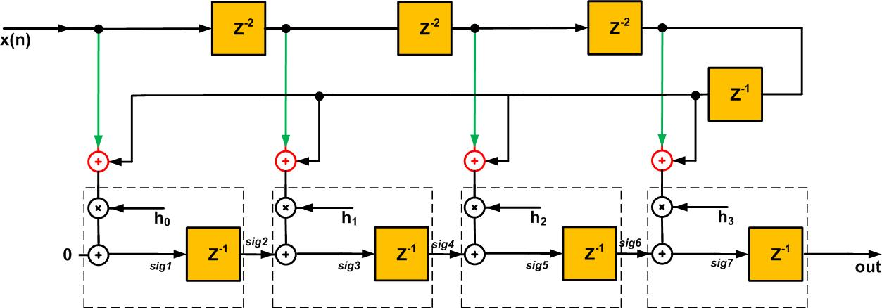

The basic FIR filter structure follows a direct form architecture. The input signal $x[n]$is passed through a series of delay elements. Each delayed sample is multiplied with a corresponding coefficient, and the results are summed to produce the output signal $y[n]$.
Mathematically, the FIR filter operation is given by:
$$y[n]=\sum_{k=0}^{15}{h[k]⋅x[n-k]}$$
where:
- $x[n]$= Input signal
- $h[k]$= Filter coefficients
- $y[n]$= Output signal
In a 16-tap FIR filter:
- 16 multipliers are required
- 15 delay elements are required
- 15 additions are required
Each block plays a crucial role in shaping the frequency response of the filter. The coefficients determine which frequencies are allowed and which are attenuated.

3.Wallace Tree Adder Architecture
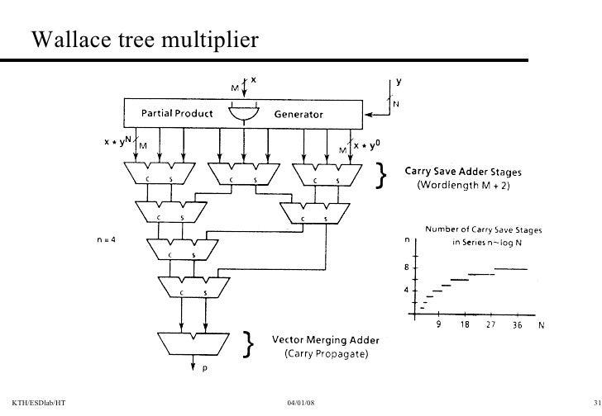
In conventional FIR filters, the outputs of multipliers are added sequentially, which increases delay. To overcome this, a Wallace Tree structure is used in this design.
The Wallace Tree is a hardware-efficient method used to sum multiple binary numbers simultaneously. Instead of adding numbers one after another, it reduces multiple operands in parallel using layers of:
- Half Adders
- Full Adders
Working of Wallace Tree
- All multiplication outputs are treated as partial products
- These products are grouped and reduced simultaneously
- At each stage, the number of operands is reduced
- Finally, only two values remain, which are added to produce output
Advantages
- Reduces addition delay significantly
- Performs parallel processing
- Improves speed and throughput
- Minimizes critical path
As discussed in research studies , using optimized arithmetic structures like Wallace Tree can improve performance by 30–40% compared to conventional adders.

4.Pipelined Architecture
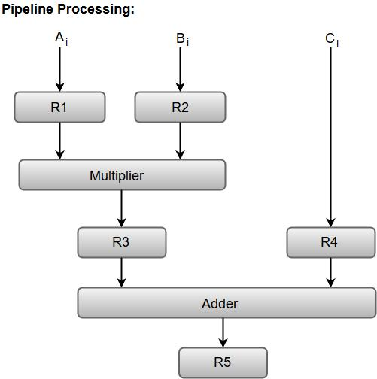

To further enhance performance, pipelining is introduced in the architecture. Pipelining divides the entire operation into multiple stages by inserting registers between operations.
Pipeline Stages
Stage 1: Input and Multiplication
- Input signal enters delay line
- Parallel multiplication with coefficients
Stage 2: Partial Product Reduction
- Wallace Tree reduces multiple products
- Intermediate results stored in registers
Stage 3: Final Addition
- Remaining values combined
- Final output generated
Stage 4: Output Stage
- Output scaled and stored
- Sent to next system

5.Advantages of Proposed Architecture

The combination of Wallace Tree and pipelining provides several advantages:
- High-Speed Operation: Achieves ≥100 MHz
- Reduced Critical Path Delay: Due to pipelining
- Parallel Processing: Faster computation
- Efficient Resource Utilization: Optimized FPGA usage
- Real-Time Capability: Suitable for audio processing
6.Design Flow

The complete design flow of the system is as follows:
- MATLAB Design
  - Generate filter coefficients
  - Verify frequency response
- Verilog Implementation
  - Design FIR filter architecture
  - Implement Wallace Tree
- Simulation
  - Test using testbench
  - Compare outputs
- FPGA Implementation
  - Synthesize using Vivado
  - Generate bitstream
- Timing Analysis
  - Perform Static Timing Analysis
  - Ensure ≥100 MHz operation

METHODOLOGY:

Overview of Methodology
The methodology of this project involves a systematic approach to design, implement, and verify a high-performance FIR filter. The entire process is divided into multiple stages, starting from filter design to hardware implementation and performance analysis. Each stage ensures that the system meets the required specifications in terms of speed, accuracy, and efficiency.
The methodology integrates both software-based design (MATLAB) and hardware-based implementation (Verilog + FPGA). MATLAB is used for designing and analyzing the filter, while Verilog HDL and Xilinx Vivado are used for hardware realization and optimization.

Overall Design Flow
The overall workflow of the project is as follows:
- Specification Definition
- MATLAB-Based Filter Design
- Coefficient Generation
- Verilog Implementation
- Simulation and Verification
- FPGA Synthesis and Implementation
- Timing Analysis
Each stage is explained in detail below.

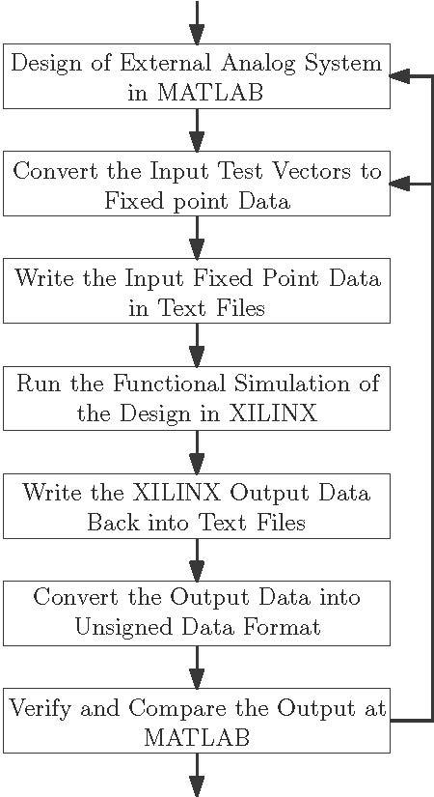
Step 1: Filter Design Using MATLAB
The first step in the methodology is designing the FIR filter using MATLAB. The design specifications include:
- Sampling Frequency: 48 kHz
- Passband Frequency: 3.5 kHz
- Stopband Frequency: 4.5 kHz
- Filter Order: 16 taps
Using these specifications, the filter is designed using the Parks–McClellan algorithm, which provides an optimal equiripple response.
Key Tasks:
- Define frequency bands
- Generate coefficients
- Plot frequency response
Outcome:
- Accurate filter coefficients
- Verified magnitude and phase response

Step 2: Coefficient Quantization

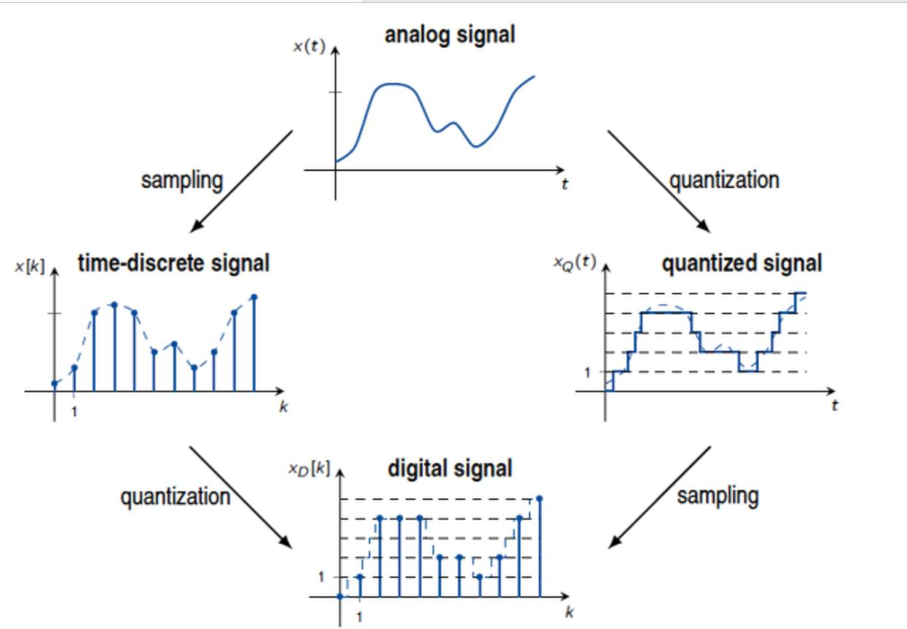
The coefficients generated in MATLAB are in floating-point format. However, hardware implementation requires fixed-point representation.
Process:
- Scale coefficients using 16-bit representation
- Convert to integer values
- Minimize quantization error
Importance:
- Ensures compatibility with FPGA
- Maintains accuracy of filter response

Step 3: Verilog HDL Implementation
The FIR filter is implemented using Verilog HDL, which describes the hardware structure.
Main Components Implemented:
- Shift registers (delay elements)
- Multipliers
- Wallace Tree adders
- Pipeline registers
Design Approach:
- Parallel computation
- Modular coding
- Efficient resource usage
This step translates the mathematical model of FIR filtering into a hardware design.

Step 4: Simulation and Verification
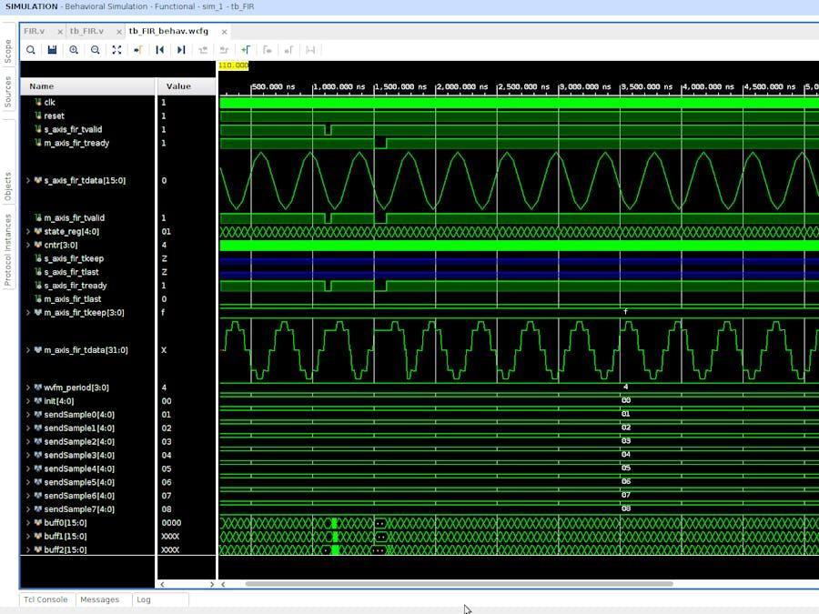

Before hardware implementation, the design is verified through simulation.
Procedure:
- Create testbench in Verilog
- Apply input test signals
- Observe output waveform
Verification:
- Compare output with MATLAB results
- Ensure correct filtering behavior
Outcome:
- Functional correctness confirmed

Step 5: FPGA Implementation (Vivado)
The verified Verilog code is synthesized and implemented using Xilinx Vivado.
Steps:
- Synthesis → Convert HDL to logic gates
- Implementation → Map design to FPGA resources
- Bitstream Generation → Create hardware file
Resources Used:
- LUTs (logic operations)
- DSP blocks (multiplication)
- Flip-flops (pipeline registers)

Step 6: Static Timing Analysis (STA)
Static Timing Analysis is performed to ensure the design meets timing requirements.
Key Parameters:
- Setup Time
- Hold Time
- Critical Path Delay
- Slack
Goal:
- Achieve positive slack
- Ensure ≥100 MHz clock frequency

Step 7: Performance Evaluation
The final step involves analyzing system performance.
Metrics Evaluated:
- Clock frequency
- Latency
- Throughput
- Resource utilization
Outcome:
- High-speed operation achieved
- Efficient design validated

Summary of Methodology
The methodology combines theoretical DSP design with practical FPGA implementation. By integrating MATLAB, Verilog HDL, and Vivado tools, the project successfully achieves a high-performance FIR filter with optimized speed and accuracy.

IMPLEMENTATION DETAILS:

Overview of Implementation
The implementation of the FIR filter involves converting the designed algorithm into a hardware model using Verilog HDL and deploying it on an FPGA platform. The design focuses on achieving high speed, low latency, and efficient resource utilization by integrating a pipelined architecture and Wallace Tree adder structure.
The implementation is divided into three main stages:
- MATLAB-based filter design
- Verilog HDL hardware implementation
- FPGA synthesis and deployment
Each stage plays a critical role in ensuring the correctness and performance of the system.

MATLAB-Based Filter Design
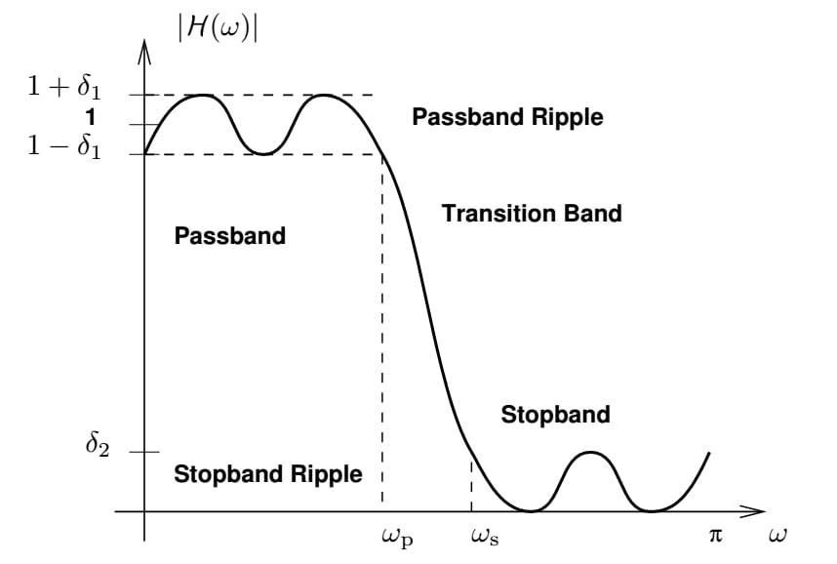
MATLAB is used to design the FIR filter and generate the required coefficients based on given specifications.
Design Specifications:
- Sampling Frequency: 48 kHz
- Passband Frequency: 3.5 kHz
- Stopband Frequency: 4.5 kHz
- Filter Order: 16 taps
Process:
- Used Parks–McClellan algorithm
- Generated optimal coefficients
- Analyzed frequency response
Output:
- Coefficient values
- Magnitude response plot
- Phase response
This stage ensures that the filter meets the desired frequency characteristics before hardware implementation.

Coefficient Generation and Quantization
The coefficients generated in MATLAB are in floating-point format, which must be converted into fixed-point representation for FPGA implementation.
Steps Involved:
- Scaling coefficients using 16-bit precision
- Converting to signed integers
- Representing in hexadecimal format
Example:
- Floating value → Fixed-point → Hexadecimal
Importance:
- Ensures compatibility with hardware
- Reduces memory usage
- Maintains computational efficiency

Verilog HDL Implementation
The FIR filter is implemented using Verilog HDL by describing the hardware components required for filtering.
Key Modules Implemented:
- Delay Line (Shift Register):
  - Stores previous input samples
  - Implements time delay
- Multipliers:
  - Multiply input samples with coefficients
  - Uses DSP blocks in FPGA
- Wallace Tree Adder:
  - Combines all multiplication outputs
  - Reduces addition delay
- Pipeline Registers:
  - Inserted between stages
  - Improve speed and timing
Design Features:
- Parallel processing
- Modular design
- Scalable architecture
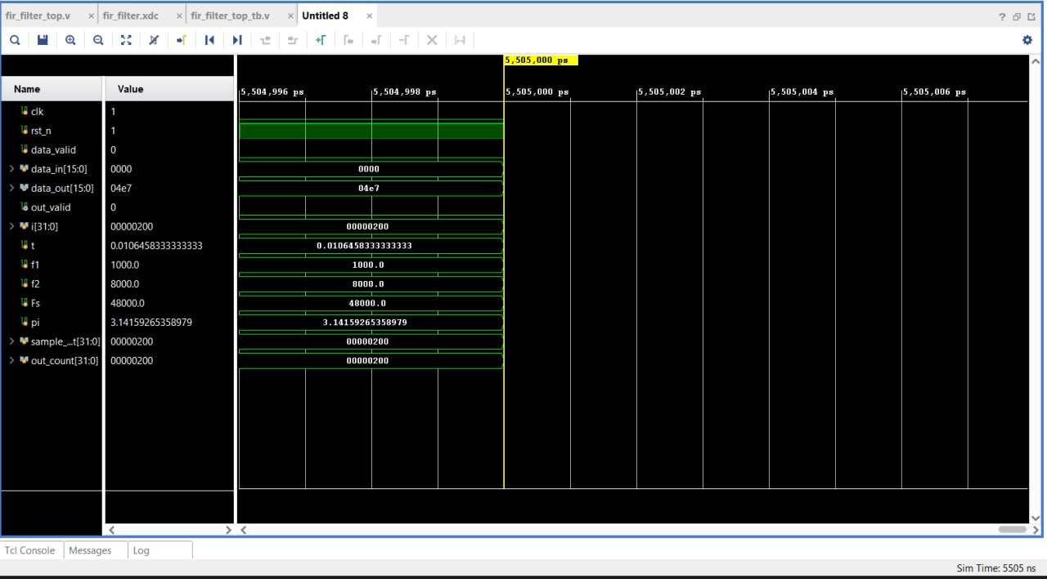
Simulation and Functional Verification
Simulation is performed to verify the correctness of the design before hardware implementation.
Steps:
- Developed testbench
- Applied input test signals
- Observed output waveforms
Verification Method:
- Compared outputs with MATLAB results
- Checked correctness of filtering
Outcome:
- Accurate filtering confirmed
- No functional errors

FPGA Implementation Using Vivado
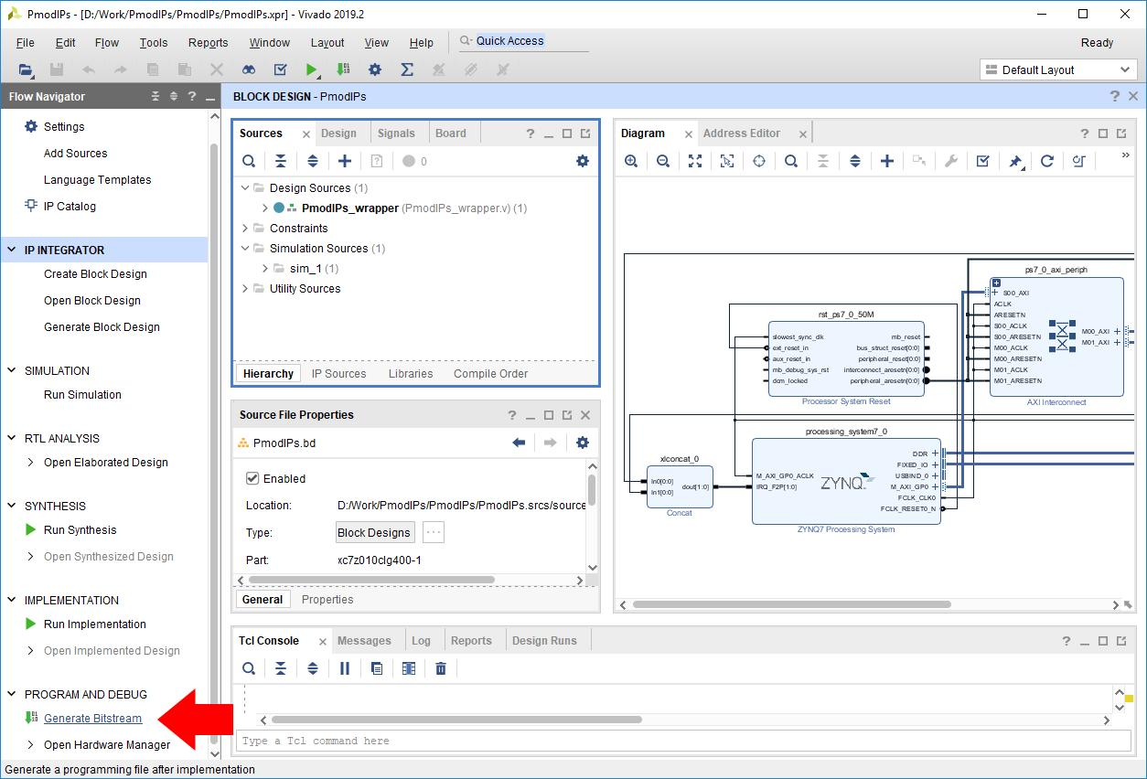

The verified Verilog design is implemented on FPGA using Xilinx Vivado.
Implementation Steps:
- Synthesis
- Implementation
- Bitstream generation
Resources Used:
- LUTs (logic operations)
- DSP blocks (multipliers)
- Flip-flops (pipeline registers)
Result:
- Efficient hardware mapping
- Optimized design
Timing Analysis
Static Timing Analysis is performed to ensure that the design meets timing requirements.
Key Parameters:
- Critical Path Delay
- Setup Time
- Hold Time
- Slack
Goal:
- Achieve positive slack
- Meet ≥100 MHz clock frequency

RESULTS AND ANALYSIS:

Overview of Results
After successful design and implementation of the 16-tap FIR filter, the system is analyzed based on functional correctness, timing performance, and resource utilization. The results demonstrate that the proposed design meets all the required specifications for real-time high-speed signal processing.
The evaluation is carried out in three main aspects:
- Functional Verification
- Timing Analysis
- Resource Utilization

Functional Verification Results

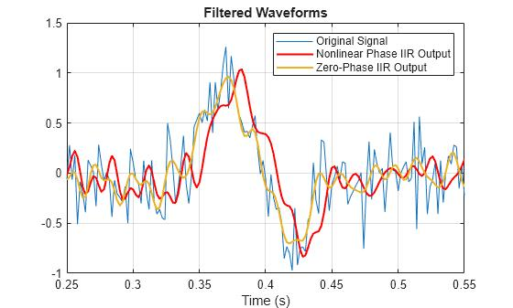

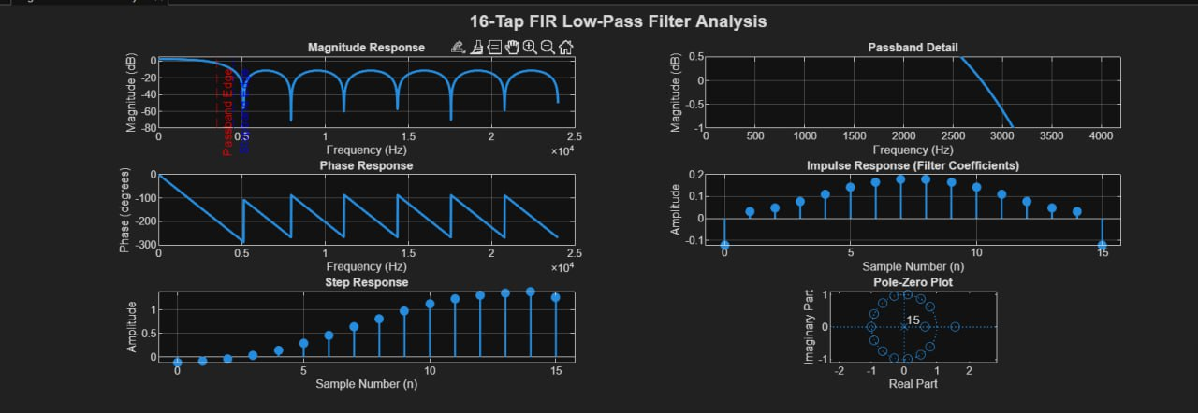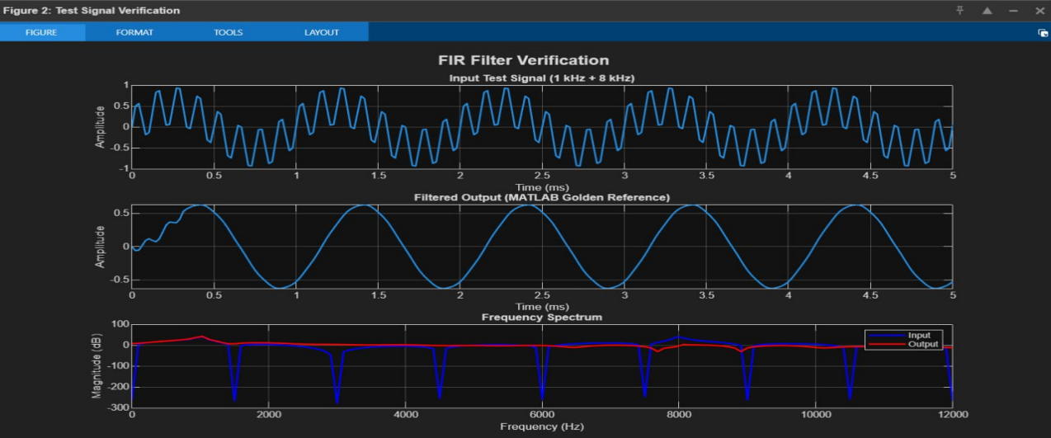
Functional verification ensures that the implemented FIR filter produces correct output.
Procedure:
- Input test signals applied through testbench
- Output waveform observed
- Compared with MATLAB golden reference
Observations:
- Low-frequency components passed successfully
- High-frequency components attenuated
- Output matches MATLAB results closely
Conclusion:
The filter operates correctly and meets the required frequency response characteristics.
Frequency Response Analysis
The frequency response of the filter is analyzed to verify its performance.
Key Parameters:
- Passband: 0 – 3.5 kHz
- Stopband: Above 4.5 kHz
- Attenuation: > 60 dB
Observations:
- Flat response in passband
- Sharp transition region
- Strong attenuation in stopband
Conclusion:
The designed filter satisfies the required specifications.

Timing Analysis Results
Timing analysis is performed using Xilinx Vivado to ensure high-speed operation.
Parameters Evaluated:
- Clock Frequency
- Critical Path Delay
- Slack
Results:
- Achieved clock frequency ≥ 100 MHz
- Positive slack observed
- No timing violations
Conclusion:
The pipelined architecture successfully reduces critical path delay and meets timing requirements.
Resource Utilization
Resource utilization is analyzed to evaluate efficiency.
Resources Used:
- LUTs (Look-Up Tables)
- Flip-Flops
- DSP Blocks
Observations:
- Efficient utilization of DSP blocks for multiplication
- Moderate usage of LUTs and registers
- No resource overflow
Conclusion:
The design achieves a good balance between performance and resource usage.

Performance Evaluation
The performance of the system is evaluated based on:
1. Throughput
- One output per clock cycle
- High data processing rate
2. Latency
- Small delay due to pipelining
- Acceptable for real-time systems
3. Speed
- ≥100 MHz operation achieved
4. Accuracy
- Output matches MATLAB reference

Comparative Analysis

Parameter | Conventional FIR | Proposed FIR (Wallace + Pipeline)
Speed | Low | High
Delay | High | Reduced
Throughput | Moderate | High
Efficiency | Moderate | High
Conclusion:
The proposed design significantly improves performance compared to traditional FIR implementations.

CONCLUSION:

Summary of the Work
In this project, a high-performance 16-tap low-pass FIR filter has been successfully designed and implemented using Verilog HDL on an FPGA platform. The primary objective of achieving real-time high-speed filtering has been accomplished by integrating advanced architectural techniques such as pipelining and the Wallace Tree adder structure.
The design process began with filter specification and coefficient generation using MATLAB. The coefficients were carefully analyzed and converted into fixed-point format suitable for hardware implementation. The FIR filter architecture was then modeled in Verilog HDL, incorporating shift registers, multipliers, Wallace Tree adders, and pipeline registers to enhance performance.
Simulation and functional verification were carried out using a testbench, and the output was compared with MATLAB results to ensure correctness. The design was then synthesized and implemented using Xilinx Vivado, where resource utilization and timing performance were analyzed.

Key Achievements
The following major outcomes were achieved in this project:
- Successful design of a 16-tap FIR filter
- Accurate coefficient generation using MATLAB
- Efficient hardware implementation using Verilog HDL
- Integration of Wallace Tree for faster addition
- Implementation of pipelined architecture for speed improvement
- Achievement of clock frequency ≥ 100 MHz
- Successful Static Timing Analysis with positive slack
- Accurate output matching MATLAB golden reference

Overall Conclusion
The results clearly demonstrate that the proposed FIR filter design is capable of high-speed real-time signal processing. The use of Wallace Tree significantly reduces addition delay, while pipelining minimizes the critical path, enabling higher operating frequency.
The design achieves a balance between performance, accuracy, and resource utilization, making it suitable for practical applications in digital signal processing systems. The project successfully validates the effectiveness of combining advanced hardware optimization techniques with FPGA-based implementation.

FUTURE SCOPE:

Possible Improvements
Although the current design achieves high performance, several enhancements can be made in the future:
- Increasing filter order (e.g., 32-tap or 64-tap FIR filter)
- Improving precision using higher bit-width representation
- Optimizing power consumption for low-power applications
- Implementing dynamic coefficient updating

Advanced Extensions
The project can be extended to more advanced applications and techniques:
- Adaptive FIR Filters: Automatically adjust coefficients based on input signal
- Multirate Signal Processing: Use in decimation and interpolation systems
- ASIC Implementation: Convert FPGA design into custom chip for higher efficiency
- Real-Time Audio Systems: Integration with microphones and speakers

Research Opportunities
Further research can be carried out in the following areas:
- Optimization of multiplier architectures (Booth, Wallace, Dadda)
- Use of Machine Learning in adaptive filtering
- High-speed DSP system design using advanced FPGA platforms
- Exploring parallel and systolic architectures

REFERENCES:

- J.G. Proakis, Digital Signal Processing
- S.K. Mitra, Digital Signal Processing: A Computer-Based Approach
- Xilinx Vivado Design Suite User Guide
- MATLAB Signal Processing Toolbox Documentation
- “Implementation of Digital Filter Using Verilog HDL”, IJRASET
- IEEE Papers on High-Speed FIR Filter Design

